IDC Interactive Public Reporting Engine User Guide
The Interactive Public Reporting Engine uses the IDEA Section 618 data states submit to OSEP to create easy-to-read charts and graphs. Links redirect you away from the IDC website to data displays built with ClicData. The data displays are for the following datasets that OSEP publishes:
Part B
- Child Count and Educational Environments;
- Personnel;
- Exiting;
- Discipline;
- Assessment;
- Dispute Resolution; and
- Maintenance of Effort Reduction and Coordinated Early Intervening Services; and
Part C
- Child Count and Settings;
- Exiting; and
- Dispute Resolution.
Each display contains data for individual states and territories as well as national totals, with the exception of the assessment data displays. Assessment data cannot be totaled nationally due to differences in assessments that states use to determine levels of proficiency. This guide provides an overview of the functionality in each data display, including:
- Changing the selected year and state
- Accessing data documentation and notes
- Using dropdown menus to filter data
- Understanding the meaning of special symbols

Changing the Selected Year and State
At the top right corner of every data display are two dropdown menus that allow you to select the year and state the tool is visualizing. A sample of the dropdown menus follows.
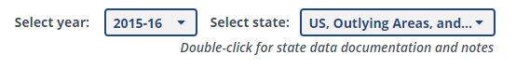
To change the year of data displayed, use the dropdown option to the left labeled “Select year.” Clicking on the dropdown menu will provide a list of years available for selection, and clicking on one of those years will update the data display based on that selection.
Similarly, to change the state displayed, use the dropdown option on the right labeled “Select state.” Clicking on the dropdown menu will provide a list of states available for selection, and clicking on one of those states will update the data display based on that selection.
Accessing Data Documentation and Notes
In addition to providing dropdown menus for changing the year and state of the data displayed, the top right of each data display also includes a link to data documentation and notes, which include information about what each dataset contains as well as explanatory notes from states. Users should review the documentation to ensure they are able to interpret the data correctly.
To access the link directly from a data display, double click on the text labeled “Double-click for state data documentation and notes” beneath the dropdown options. Alternatively, you may access the documentation directly by clicking the following link: https://www2.ed.gov/programs/osepidea/618-data/collection-documentation/index.html.
Using Dropdown Menus to Filter Data
Aside from the year and state dropdown menus at the top right, data displays may also contain additional dropdown menus at different positions to allow for additional filtering of the data. These filters work in conjunction with the year and state dropdowns at the top of each data display.
For example, the Part B: Exiting data dashboard allows users to update the following set of charts and tables based on the selected reason for exit:
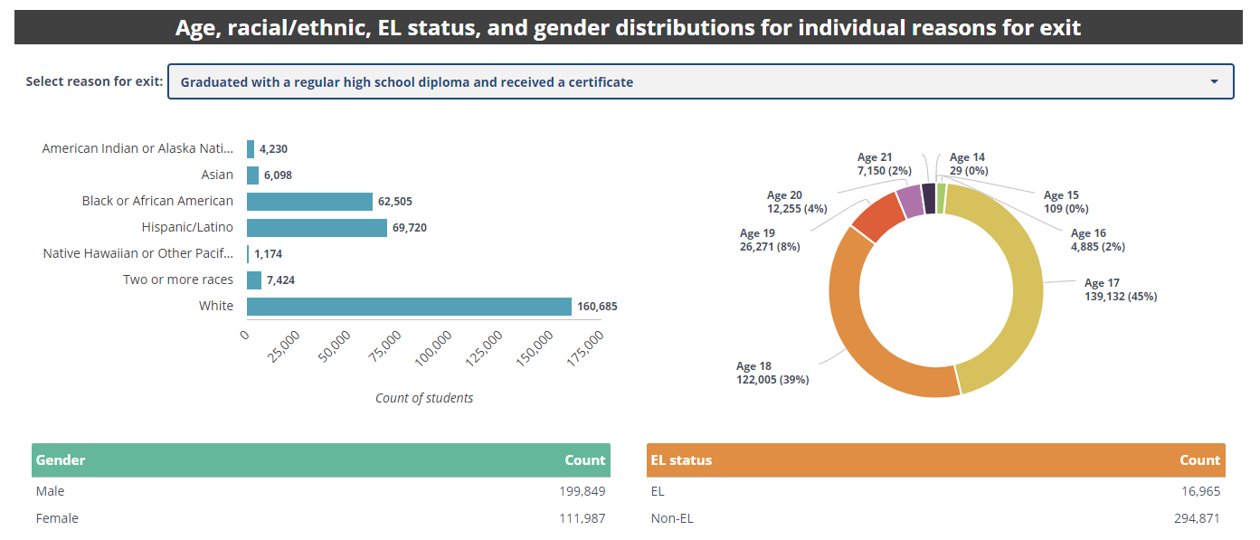

Clicking on the dropdown labeled “Select reason for exit” will display a list of options for additional filtering. For example, changing the selected reason from “Graduated with a regular high school diploma and received a certificate” in the preceding screenshot to “Total exiting special education” will update the data in the charts and tables below the filter, resulting in the following:
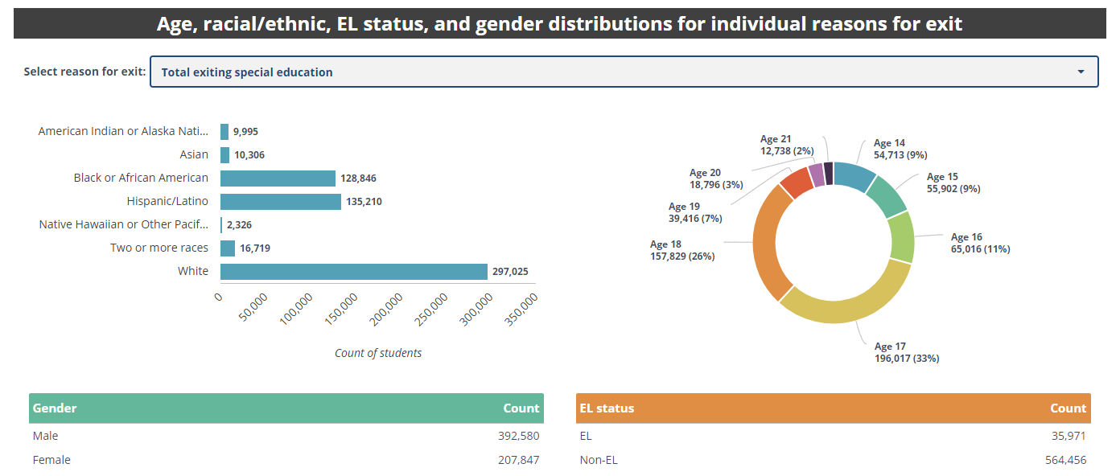
Furthermore, in some cases, there may be multiple dropdowns that work in conjunction with each other. For example, the three dropdown menus – “Select reason for exit,” “Select disability,” and “Select demographic” – in the following screenshot work together to filter the data in the bar chart below it. 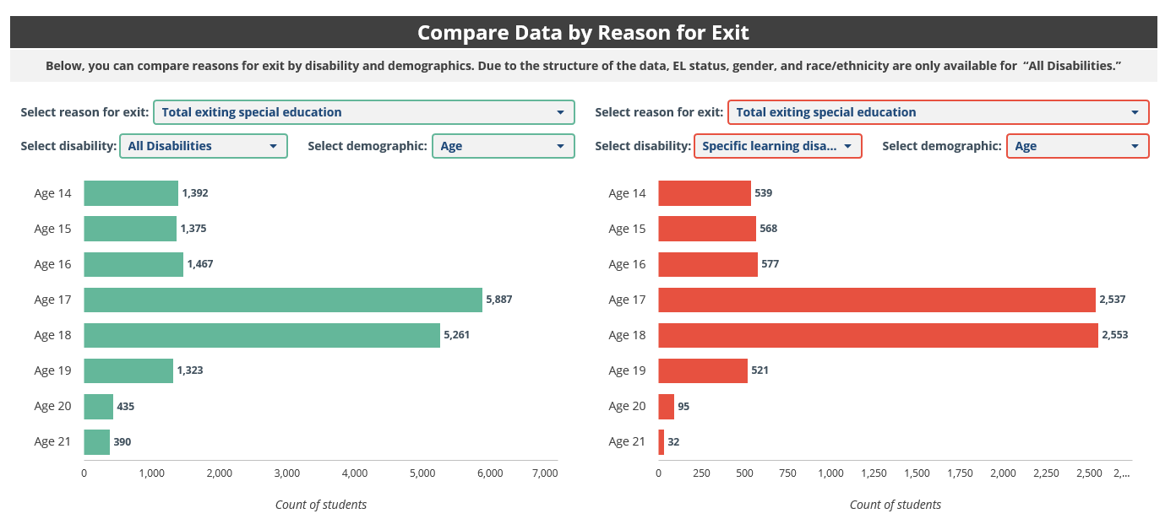

Users can view the data for “Total exiting special education” or other exiting reason by different combinations of disability and demographics by making different selections. For example, to view the “All Disabilities” data by “English Learner Status,” change the demographic in the “Select demographic” dropdown menu to “English Learner Status,” as shown in the following display:
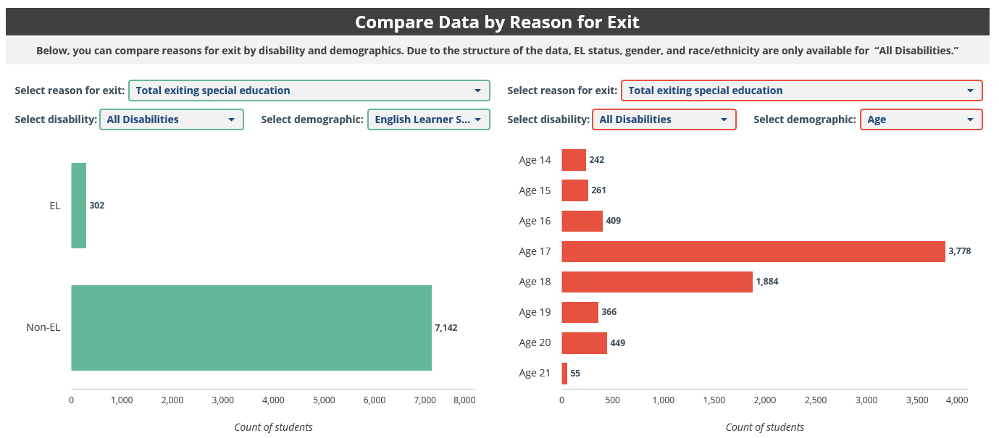
Understanding the Meaning of Special Symbols
Occasionally, the data display may show one or more of the following symbols:
- (Data not available): Data for a particular combination of filter selections is not part of the dataset or is not available.
<= 3 (Data suppressed due to small cell size): OSEP suppressed the data point to protect privacy because the cell count is 3 or fewer, which could allow for identification of individuals. This symbol is used only in the assessment data set.
x (Data suppressed due to small cell size): OSEP suppressed the data point to protect privacy because the cell count is below the reporting threshold, which could allow for identification of individuals. This is the suppression symbol used in all files except for assessment.
* (Data suppressed for data quality): OSEP suppressed the data not for privacy, but because of concerns about the quality of the data the state submitted to OSEP.

Due to differences in assessment data file structure across years, the tool reports data for each school year (2013–14, 2014–15, and 2015–16) in three separate data displays. Therefore, these displays do not include the option to change the year of data displayed.

