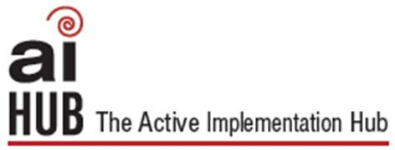
Local Program/District Initiative Inventory

This tool can be used to guide your team’s review of past and current programs to get a clear picture of successful strategies, and challenges, along with existing mandates and resource commitments.

Previous Local/District Initiatives
Initiative | Expected  Outcome | Target  Population | Mandated/  Regulatory Activity? Yes/No | Financial  Commitment  (1=low, 5=high) | Relation to  District Priorities  & Strategic Plan  (1=low, 5=high) | Level of Success  (1=low, 5=high) | Evidence of  Outcomes
 |  |  |  Yes   No | 1 2 3 4 5 | 1 2 3 4 5 | 1 2 3 4 5
 |  |  |  Yes   No | 1 2 3 4 5 | 1 2 3 4 5 | 1 2 3 4 5
 |  |  |  Yes   No | 1 2 3 4 5 | 1 2 3 4 5 | 1 2 3 4 5
 |  |  |  Yes   No | 1 2 3 4 5 | 1 2 3 4 5 | 1 2 3 4 5
 |  |  |  Yes   No | 1 2 3 4 5 | 1 2 3 4 5 | 1 2 3 4 5

Learn more at: http://implementation.fpg.unc.edu/

Current Local/District Initiatives
Initiative | Expected  Outcome | Target  Population | Mandated/  Regulatory Activity? Yes/No | Financial  Commitment  (1=low, 5=high) | Relation to District  Priorities & Strategic Plan (1=low, 5=high) | Level of Success  (1=low, 5=high) | Evidence of  Outcomes
 |  |  |  Yes   No | 1 2 3 4 5 | 1 2 3 4 5 | 1 2 3 4 5
 |  |  |  Yes   No | 1 2 3 4 5 | 1 2 3 4 5 | 1 2 3 4 5
 |  |  |  Yes   No | 1 2 3 4 5 | 1 2 3 4 5 | 1 2 3 4 5
 |  |  |  Yes   No | 1 2 3 4 5 | 1 2 3 4 5 | 1 2 3 4 5
 |  |  |  Yes   No | 1 2 3 4 5 | 1 2 3 4 5 | 1 2 3 4 5
Adapted from MiBLSi (4/15/10), ISSA (10/19/09), G.Sugai (1/26/01)

The AI Hub, AI Modules and AI Lessons are an initiative of the State Implementation & Scaling‐up of Evidence‐based Practices Center and the National implementation Research Network

Learn more at: http://implementation.fpg.unc.edu/ 2

