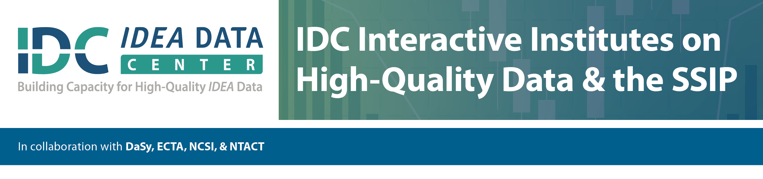

**Implications of Growth Modeling for SSIP**

**Worksheet 2**

**What domain/outcome have you selected (reading, math, social emotional)?**

**What populations are you focusing on?**

**What data either exist or would need to exist?**

**What is your basis of comparison?**

**What is your SIMR?**

**What growth model might work (trajectory, projection, value table, CGP)?**